Java Mail Sender
JavaMailSender is an interface provided by the Spring Framework that allows Java applications to send emails programmatically using an SMTP (Simple Mail Transfer Protocol) server.
It simplifies email functionality by providing methods to send emails without manually managing all the low-level JavaMail API operations.
For example, using JavaMailSender, we can develop applications that:
- Send registration confirmation emails.
- Send OTP verification emails.
- Send password reset links.
- Send order confirmation emails.
- Send notifications and alerts.
- Send emails with attachments.
- JavaMailSender is an interface available in the Spring Framework's spring-context-support module.
  - org.springframework.mail.javamail.JavaMailSender
It extends the MailSender interface.
Some important methods are:
Method | Description
send(SimpleMailMessage message) | Sends a simple text email.
send(MimeMessage message) | Sends an email supporting HTML and attachments.
createMimeMessage() | Creates a MimeMessage object.

How does Java Mail Sender Works?
Consider an application where a user is trying to register
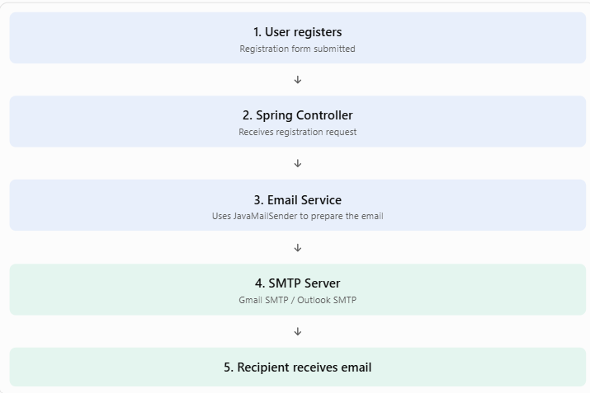
Steps to use Java Mail Sender API
  - Add dependencies:-
<dependency>
<groupId>org.springframework.boot</groupId>
<artifactId>spring-boot-starter-mail</artifactId>
</dependency>
  - Step 2: Configure SMTP properties
In application.properties:
spring.mail.host=smtp.gmail.com
spring.mail.port=587
spring.mail.username=your_email@gmail.com
spring.mail.password=your_app_password

spring.mail.properties.mail.smtp.auth=true
spring.mail.properties.mail.smtp.starttls.enable=true
For Gmail, use a Google App Password rather than your normal Gmail password.
Step 3: Create EmailService
@Autowired
private JavaMailSender mailSender;
public void sendEmail() {

SimpleMailMessage message =
new SimpleMailMessage();
message.setTo("receiver@gmail.com");
message.setSubject("Welcome Email");
message.setText(
"Welcome to our application!"
);
mailSender.send(message);
System.out.println("Email sent successfully");
}
}
Step 3: Create EmailService
@Service
public class EmailService {
@Autowired
private JavaMailSender mailSender;
public void sendEmail() {
SimpleMailMessage message =
new SimpleMailMessage();

message.setTo("receiver@gmail.com");
message.setSubject("Welcome Email");
message.setText(
"Welcome to our application!"
);
mailSender.send(message);
System.out.println("Email sent successfully");
}}
Step 4: Create a Controller
@RestController
public class EmailController {
@Autowired
private EmailService emailService;
@GetMapping("/sendmail")
public String sendMail() {
emailService.sendEmail();
return "Email sent successfully";
}
}
Now run your Spring Boot application and open:
http://localhost:8080/sendmail
If the SMTP configuration is correct, the email will be sent.
Important classes and interfaces
Class / Interface | Purpose
JavaMailSender | Interface used to send emails.
JavaMailSenderImpl | Spring's implementation of JavaMailSender.
SimpleMailMessage | Represents a simple text email.
MimeMessage | Represents an email supporting HTML and attachments.
MimeMessageHelper | Simplifies creating HTML emails and adding attachments.

